RESOLUTION NO.__________

RE: CERTIFICATE OF APPROPRIATENESS UNDER THE
PROVISIONS OF THE ACT OF THE PENNSYLVANIA
LEGISLATURE 1961, JUNE 13, P.L. 282 (53
SECTION 8004) AND BETHLEHEM ORDINANCE NO.
3952 AS AMENDED.

WHEREAS, it is proposed to re-paint the trim on the exterior of the building at 402 N. New Street.

NOW, THEREFORE, BE IT RESOLVED by the Council of the City of Bethlehem that a Certificate of Appropriateness is hereby granted for the proposal.

Sponsored by: (s)

(s)

ADOPTED BY COUNCIL THIS DAY OF

(s)
President of Council

ATTEST:

(s)
City Clerk

HISTORICAL & ARCHITECTURAL REVIEW BOARD

The applicant is proposing to re-paint the trim on the exterior of the building at 402 N. New Street.
APPLICATION #1:

Church Street Market, LLC
55 E. Church Street
Bethlehem, PA 18018

OWNER:

__________________________________________________________________________

The Board upon motion by Phil Roeder and seconded by Beth Starbuck adopted the proposal that City Council issue a Certificate of Appropriateness for the following:

- Doors and shutter color to match the existing color.

- Colors will be from the Benjamin Moore Historic Colors. Beige will be Bleeker Beige #HC-80 for light colored surfaces and Alexandria Beige #HC-77 for the darker accent colors and the garage siding.

- Downspouts on the garage to be painted Alexandria Beige to match the siding color with the brackets supporting the garage roof painted either Beige.

4. The motion was unanimously approved.
__________________________________________________________________________

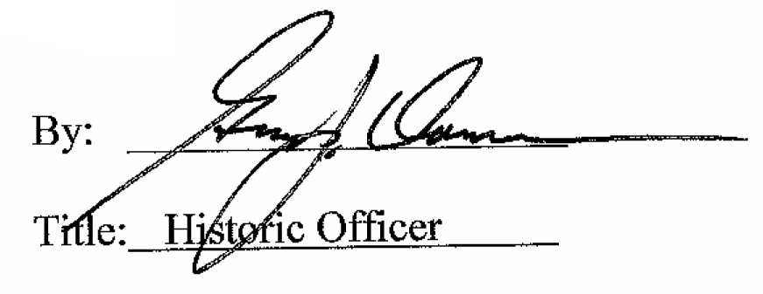

Date of Meeting: November 2, 2016

